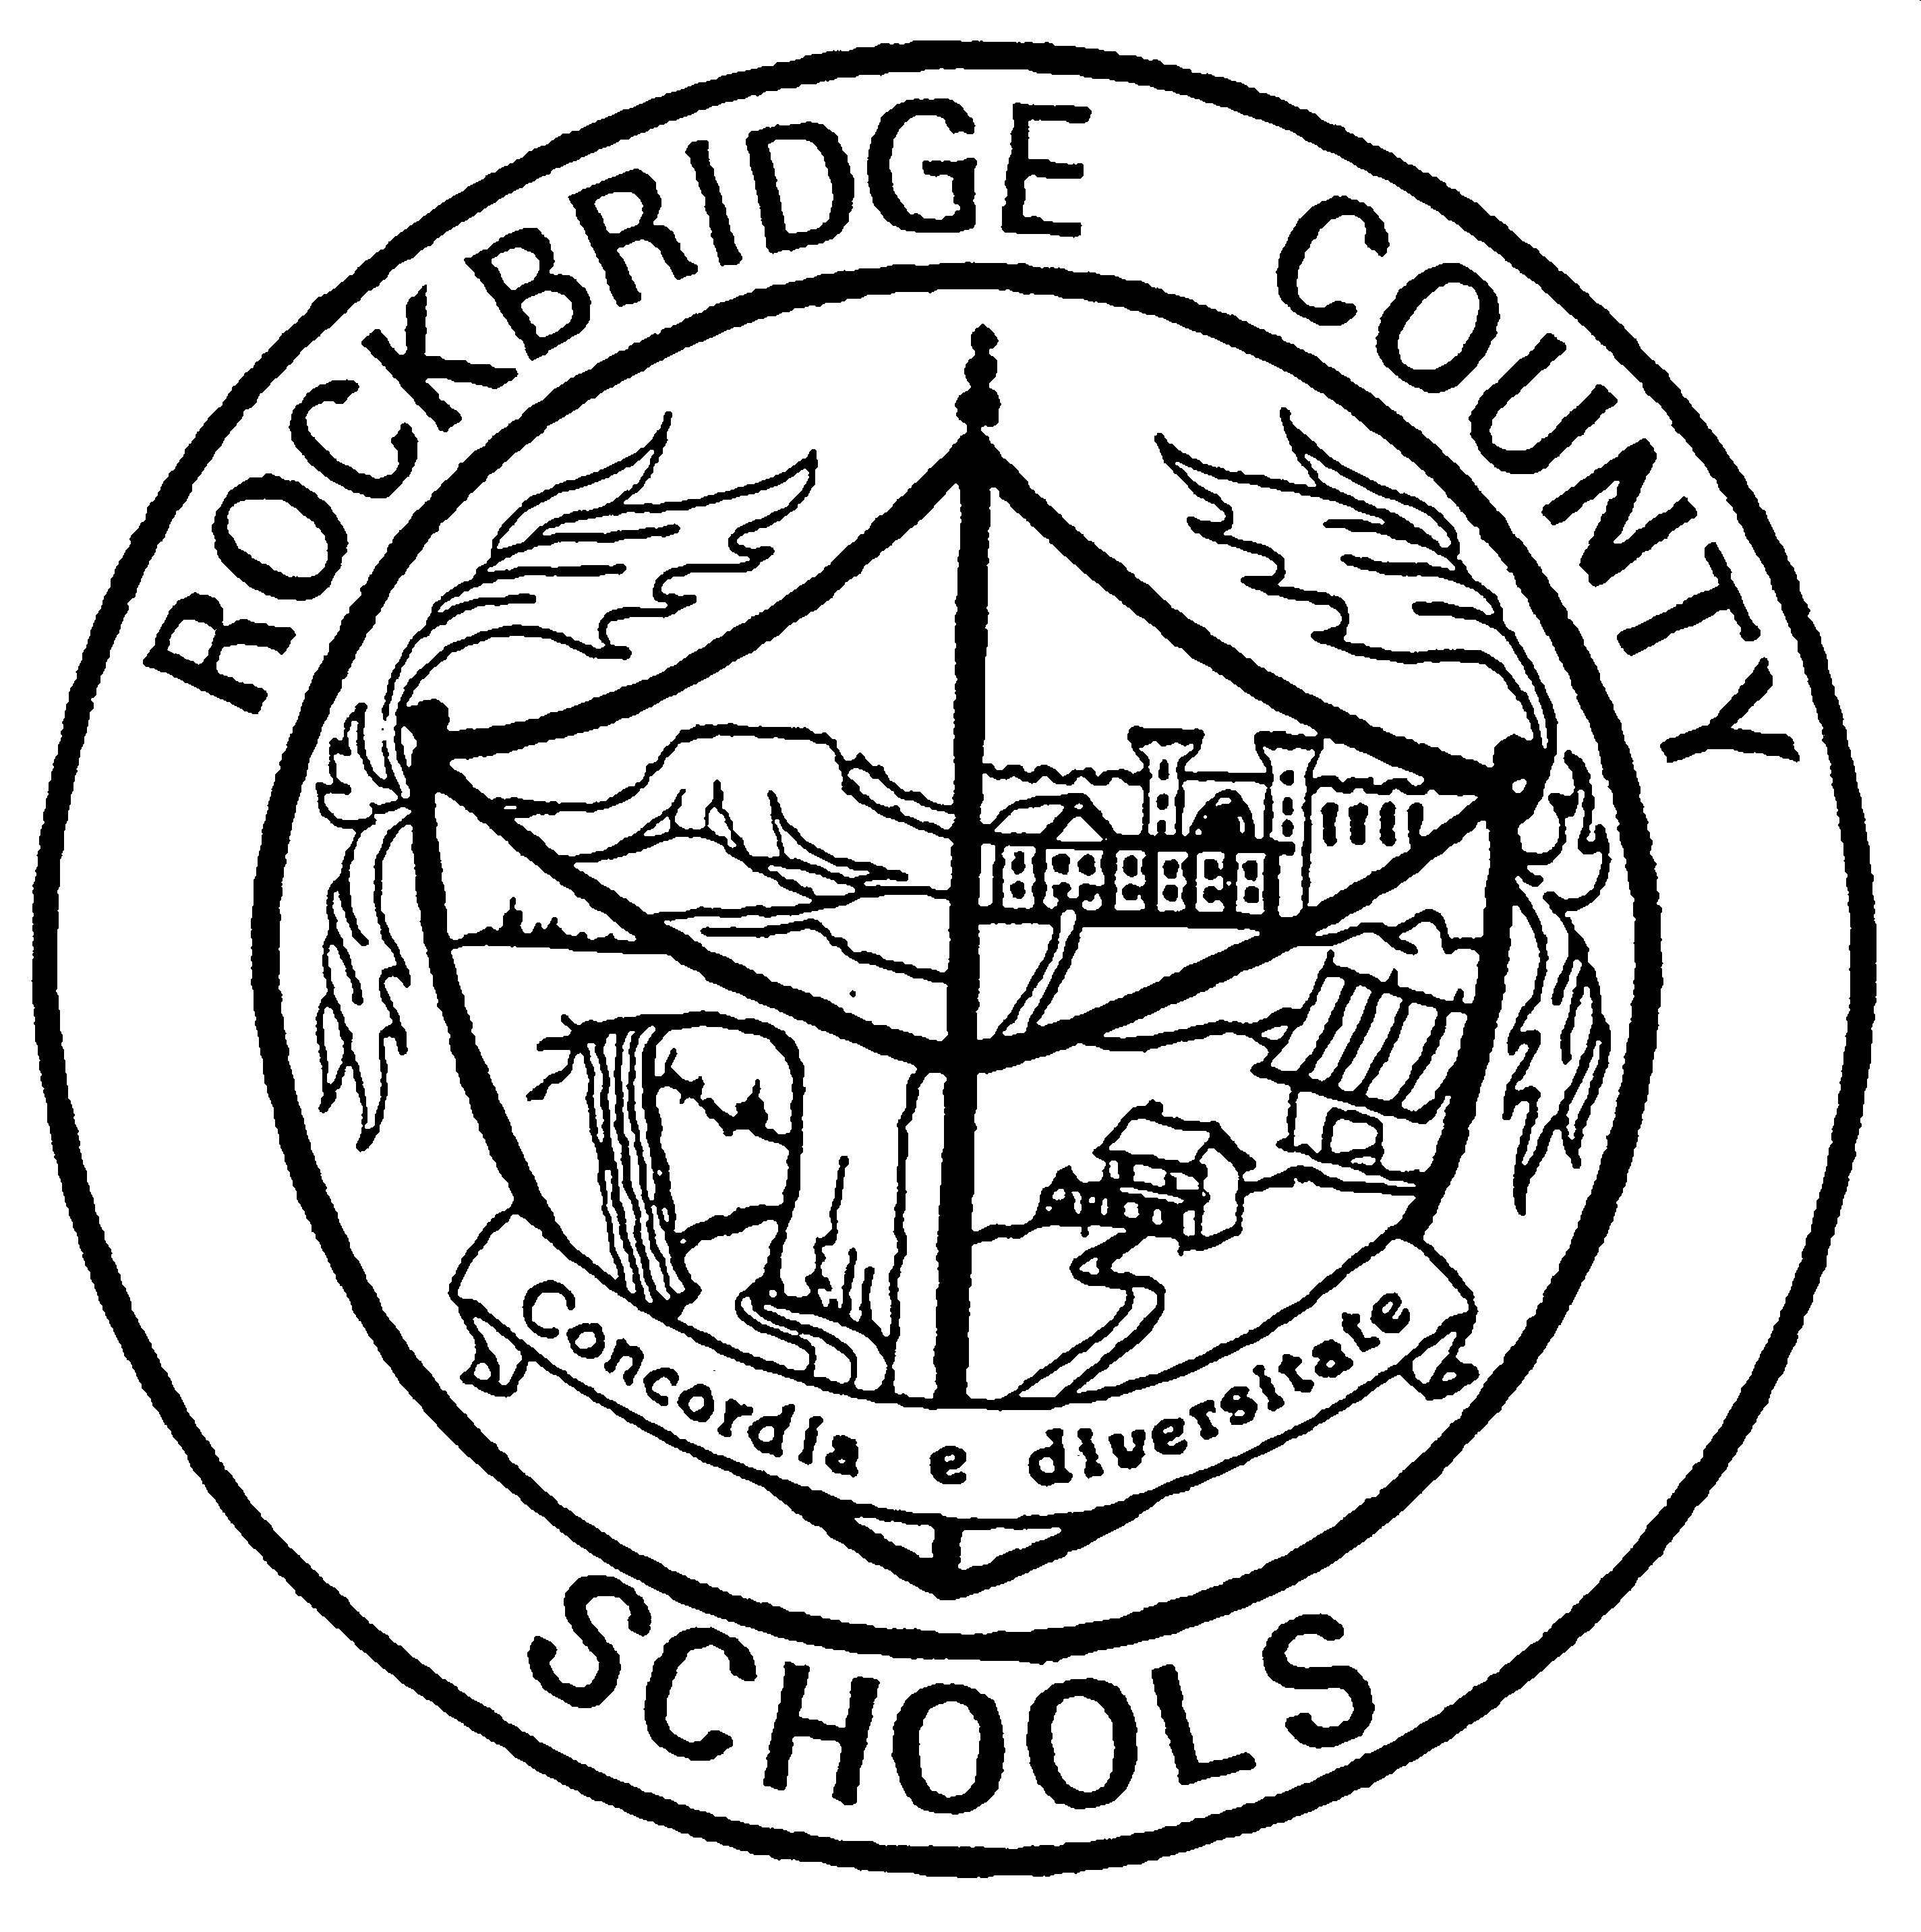
Rockbridge County Schools
Health Update- Scoliosis

Dear Parents/Guardian,

In accordance with Virginia State law, parents of students in grades five through ten will receive this yearly information sheet containing important facts about scoliosis and scoliosis screening.

Scoliosis is an abnormal curvature or turning of the spine. It affects 2-3% of the population or an estimated 600,000 people in the United States. If left untreated, it can progress to a serious problem, causing back pain and degenerative arthritis of the spine. It may lead to disk disease or sciatica. It can also threaten the psychological well-being of a young adult when there is an obvious deformity. Although scoliosis may result from an injury, a birth defect, or a crippling disease, 90% of cases are from unknown causes. It may run in families and affects girls seven times more often than boys. It most frequently develops during the growth spurt between ages 10 and 15, but can also develop or progress later in life. Early detection and intervention may prevent further structural deformity and resulting secondary problems.

Scoliosis screening is an observation of the student's spine while standing as well as performing a forward bend. A scoliometer, a device for measuring the amount of abnormal curvature in the spine, may also be used during screening. Treatment for scoliosis runs the gamut between no treatment needed to bracing of the spine to spinal fusion surgery.

Since the development of scoliosis is gradual and usually painless, scoliosis may develop without the parent or child being aware. It is important for parents to monitor their child’s development during these growing years. The signs of scoliosis may include uneven shoulders, a shoulder blade that appears more prominent than the other, uneven waistline, one hip higher than the other, and/or a leaning to one side. If you have concerns about your child's spinal health, contact your school nurse or your private care physician.

